Name________________________________________________Period______
8th Grade End of Year Study Guide
Chemistry
- How are atoms related to molecules?

- Has our theory of atomic structure ever changed? If so, why?

- How many protons, neutrons, and electrons does phosphorous have?

Protons: Neutrons: Electrons:

- How many protons, neutrons, and electrons does arsenic have?
Protons: Neutrons: Electrons:

- How many protons, neutrons, and electrons does flourine have?

Protons: Neutrons: Electrons:

- How many protons, neutrons, and electrons does copper have?
Protons: Neutrons: Electrons:

- How many protons, neutrons, and electrons does boron have?

Protons: Neutrons: Electrons:

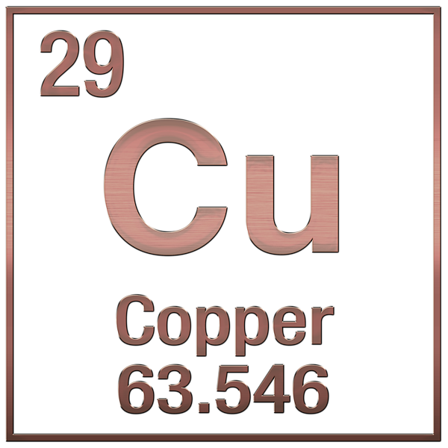
- How do we decide which substances to use for a particular function?

- Why do we use rubber for tires?

- Why do we use diamonds for drill bits?

- Why do we use helium and not hydrogen in balloons?

- How could you change a solid to a gas?
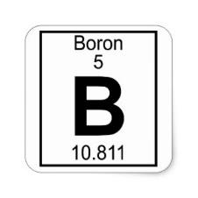
- How could you change a gas to a liquid?

- How could you change a liquid to a solid?

- How could you change a liquid to a gas?

- How are temperature and density related?

- If you heat up a balloon, what happens to its density?

- What are 4 phenomena could indicate that a chemical reaction has taken place?

- What natural resource did your synthetic substance come from?

- Why is your synthetic material better than the natural material?

- Draw what a solid, liquid, and gas would look like in a beaker.

- Which state is generally the most dense and why?

- 9,756 grams of a substance occupy 35,000 cubic centimeters of space. Calculate the density of the substance.
- What advantage does a synthetic sweetener like splenda have over a natural sweetener like sugar?

- Draw a model of a chemical reaction that obeys the law of conservation of mass.

- If you start out with 100 kilograms of wood and burn it, the ashes only weigh 1.5 kilograms. Where did the other 98.5 kilograms go?

- Are phase changes chemical changes? Why?

Physics
- How would changing the amplitude change how you see light?

- How would changing the amplitude change how you hear sound?

- How would changing the frequency change how you see light?

- How would changing the frequency change how you hear sound?

- What factors determine the amount of mechanical kinetic energy a moving object has?

- What factors determine the amount of gravitational potential energy an object has?

- Why do you see a red car as red?

- Why do you see a blue car as blue?

- How is energy transferred in collisions?

- How are s waves different than p waves?

- What does waves refracting mean?

- What is an example of refraction? (include an example using both sound and light waves)

- What does waves being transmitted mean?

- What is an example of waves being transmitted? (include an example using both sound and light waves)

- What does waves being absorbed mean?

- What is an example of waves being absorbed? (include an example using both sound and light waves)

- What does waves reflected mean?

- What is an example of waves reflecting? (include an example using both sound and light waves)

- Draw a diagram showing how a light wave would look being reflected, refracted, absorbed, or transmitted when it hits a wall.

- What is the law of conservation of energy?

- Explain 2 examples that illustrate the law of conservation of energy.

- Draw and label a wave with all of its parts.

- What factor determines the amount of energy in a wave?

- What is analog technology?

- What is digital technology?

- What are some pros and cons about analog and digital technologies?

Ecology
- What is the formula for photosynthesis?

- What is the formula for cellular respiration?

- Explain in your own words what photosynthesis is and how it transforms matter.

- Explain in your own words what cellular respiration is and how it transforms matter.

- What is the relationship between photosynthesis and cellular respiration?

- How has photosynthesis changed the Earth?

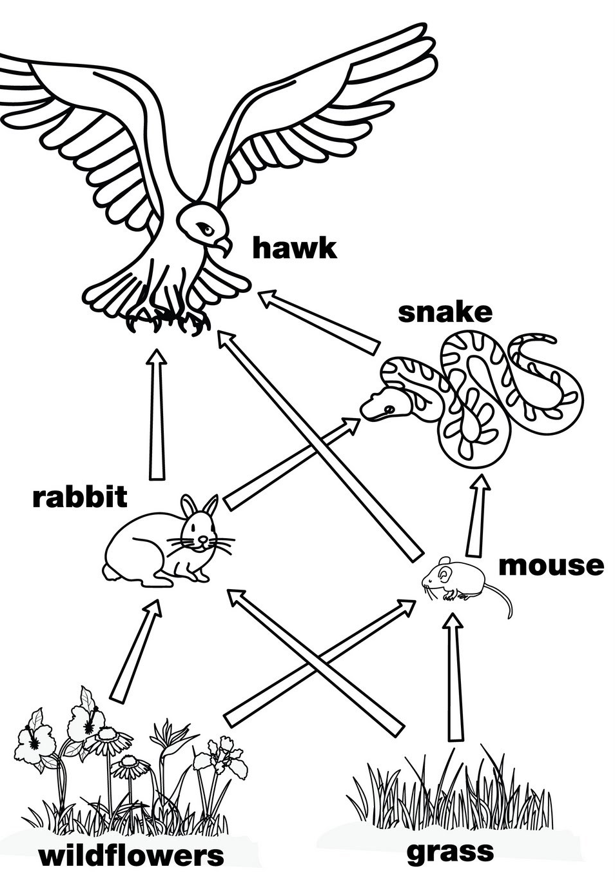
- What factors affect the rate of photosynthesis on Earth?

- How do all organisms rely on photosynthesis? Cellular respiration?

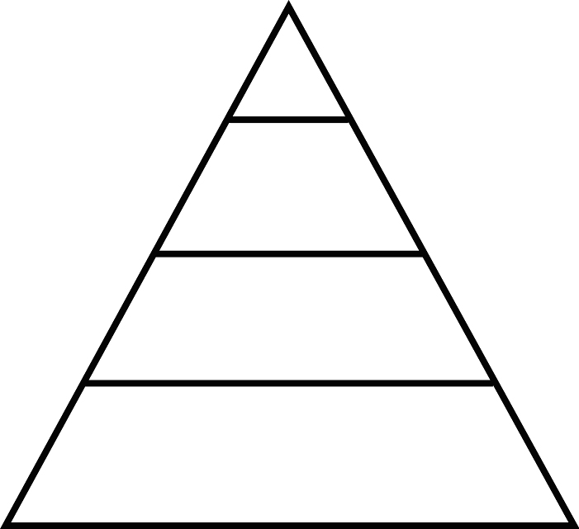
- What are the producers in this food web?

- What are the consumers in this food web?

- Fill in the energy pyramid with the organisms from the food web.⇦

- What happens to the amount of energy as you travel from the bottom of the energy pyramid to the top?

- Which organism could you take away from the food web that would cause the biggest change? Why?

- Which organism could you take away from the food web that would cause the smallest change? Why?

- What are some things that could happen if a new organism was introduced to this food web?

- Why are ecosystems delicate?

- Draw a graph that shows the levels of CO₂ in an ecosystem during the following events:

  - There are many plants but no animals in the ecosystem for 4 days
  - On day 5, 1 animal is introduced
  - On day 6, 20 animals are introduced
  - On day 10, all of the animals leave

Environmental Science
- What is the definition of a natural resource?

- Give 10 examples of natural resources

- Are natural resources evenly distributed on the Earth?

- What makes natural resources more concentrated in some areas than others?

- Why is using natural resources a double edged sword? (Why can it be good and bad for us?)

- What does the word mitigate mean?

- What does it mean to mitigate the effects of our use of natural resources?

- Why is mitigating natural resource use important?

- What has our increased use of fossil fuels done to affect the Earth system?

- What effect will rising global temperatures have on:
  - The ocean:

  - Global sea levels:

  - Sea and land ice:

- Where would you be most likely to encounter tornadoes?

- How would our knowledge about where tornadoes occur change our building practices?

- What factors make tornadoes more common in some areas?

